**Job Description – Sessional Driver (SEND children)**

Reporting to: Children & Young Adults Service Manager

Salary: £14.74 per hour

Location: Based at KCA Harrow and across the London Borough of Harrow. Regular driving between local sites and family homes.

Hours of work: Flexible

**Job summary**

You will provide safe, reliable and compassionate transport for children and young adults aged 5–25 with learning disabilities, autism, and complex needs.

This includes journeys to and from our after-school clubs, weekend clubs, and holiday provision across KCA and school-based settings within Harrow.

You’ll promote safety and wellbeing while driving, supporting children and young adults to have comfortable journeys and helping them transition between home and KCA calmly.

You practice the values of:

* Kindness in your interactions with children & young adults.
* Choice of meaningful activities that matter to the person you support.
* Ambition to engage children & young adults of all abilities to develop and enjoy.

You will promote KCA’s values, aims, policies and procedures.

Child Protection is your priority. You Speak Up against practices that do not support safeguarding and our core values. You support in person-centred way, placing the needs, preferences, and aspirations of individuals you work with at the heart of all planning and decision-making to empower children & young adults to achieve their goals, build independence and live fulfilling lives.

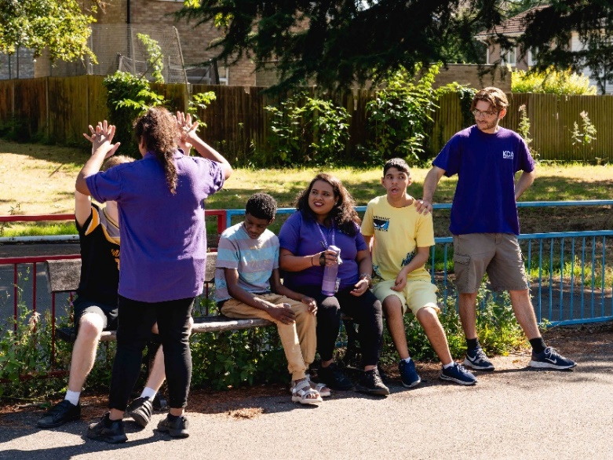

**Key responsibilities**

**Safe Transport**

* Drive a minibus to collect and drop off children and young adults safely.
* Follow scheduled routes and adapt to changing traffic, weather, and service needs.
* Work with support staff to reduce stress during journeys for passengers and keep a positive atmosphere.
* Ensure all passengers are secured safely using seatbelts, harnesses or wheelchair restraints.

**2. Support During Journeys**

* Follow support staff plan to supervise and interact appropriately with passengers during transport, promoting a calm and reassuring environment.
* Use positive behaviour support approaches and respond sensitively to distressed behaviours.
* Communicate clearly and kindly with children, families, and support staff at pick-up/drop-off points.
* You always present yourself professionally and represent KCA with courtesy and respect toward children, families, and colleagues.

**3. Vehicle Safety & Maintenance**

* Complete daily vehicle checks, report faults promptly, and maintain cleanliness and fuel levels.
* Ensure vehicle safety equipment (e.g., fire extinguishers, first aid kits) is present and functional.
* Follow KCA and legal standards for driving, safety, and vehicle compliance.
* Comply with Highway Code.
* Maintain accurate logs and records for journeys, incidents, and vehicle use.
* You follow protocols for responding to emergencies or vehicle breakdowns, ensuring passengers remain safe and informed.

**4. Safeguarding and Reporting**

* Report safeguarding concerns or incidents in line with KCA policies.
* Maintain confidentiality and promote the safety and dignity of every child and young person.
* You assist in maintaining accurate passenger records and logs for each journey.

**5. Teamwork and Flexibility**

* Communicate effectively with session leaders, deputy managers, and the admin team.
* Attend relevant team briefings, training, and induction sessions.
* Be available to work across after-school hours, weekends, and holiday periods. Short-notice cover may be required due to absence or emergencies.

**Additional Information**

* This role may require physical effort (e.g., assisting passengers, installing/removing seating).
* You will be supported by the Service Manager and expected to uphold high standards of safeguarding and professionalism.
* Full induction will be provided.
* A ‘fit to drive’ health declaration may be required as part of onboarding and must be 21 years of age to comply with insurance requirements.

|  |  |
| --- | --- |
| **Selection criteria** | |
| The values, skills, and knowledge need to demonstrate | |
| The sessional driver should | Examples that may show competence |
| Hold relevant qualifications and checks | Full UK driving licence with D1 entitlement (essential) Current enhanced DBS or willingness to obtain one. |
| Drive safely and confidently | At least 2 years of experience driving minibuses or similar vehicles.  Confident operating safely in urban and residential areas MIDAS certification (or willingness to complete) |
| Support children and young people appropriately | Desirable experience working with, or understanding of, children/young people with SEND Calm, respectful, and patient approach. |
| Communicate effectively | Able to communicate clearly and kindly with families and team members Ability to handle sensitive information professionally |
| Prioritise health and safety | Understanding of manual handling, wheelchair safety, and vehicle emergency procedures Paediatric First Aid (desirable) |
| Record and report confidently | Ability to complete journey logs, incident forms, and report faults Basic IT or written recording skills |
| Understand and manage risk | The ability to identify diverse types of risks and conduct risk assessments. |
| Safeguarding | Understanding of how to protect children and young adults from harm and safeguarding protocols. |
| Health and safety | A clear understanding of the requirements for a safe and heathy environment for people we support and staff. |
| Value equity, promote diversity, and champion inclusion | Commitment to KCA’s inclusive values Ability to work in a culturally diverse environment |
| Availability | Work flexibly around service operational needs. |

