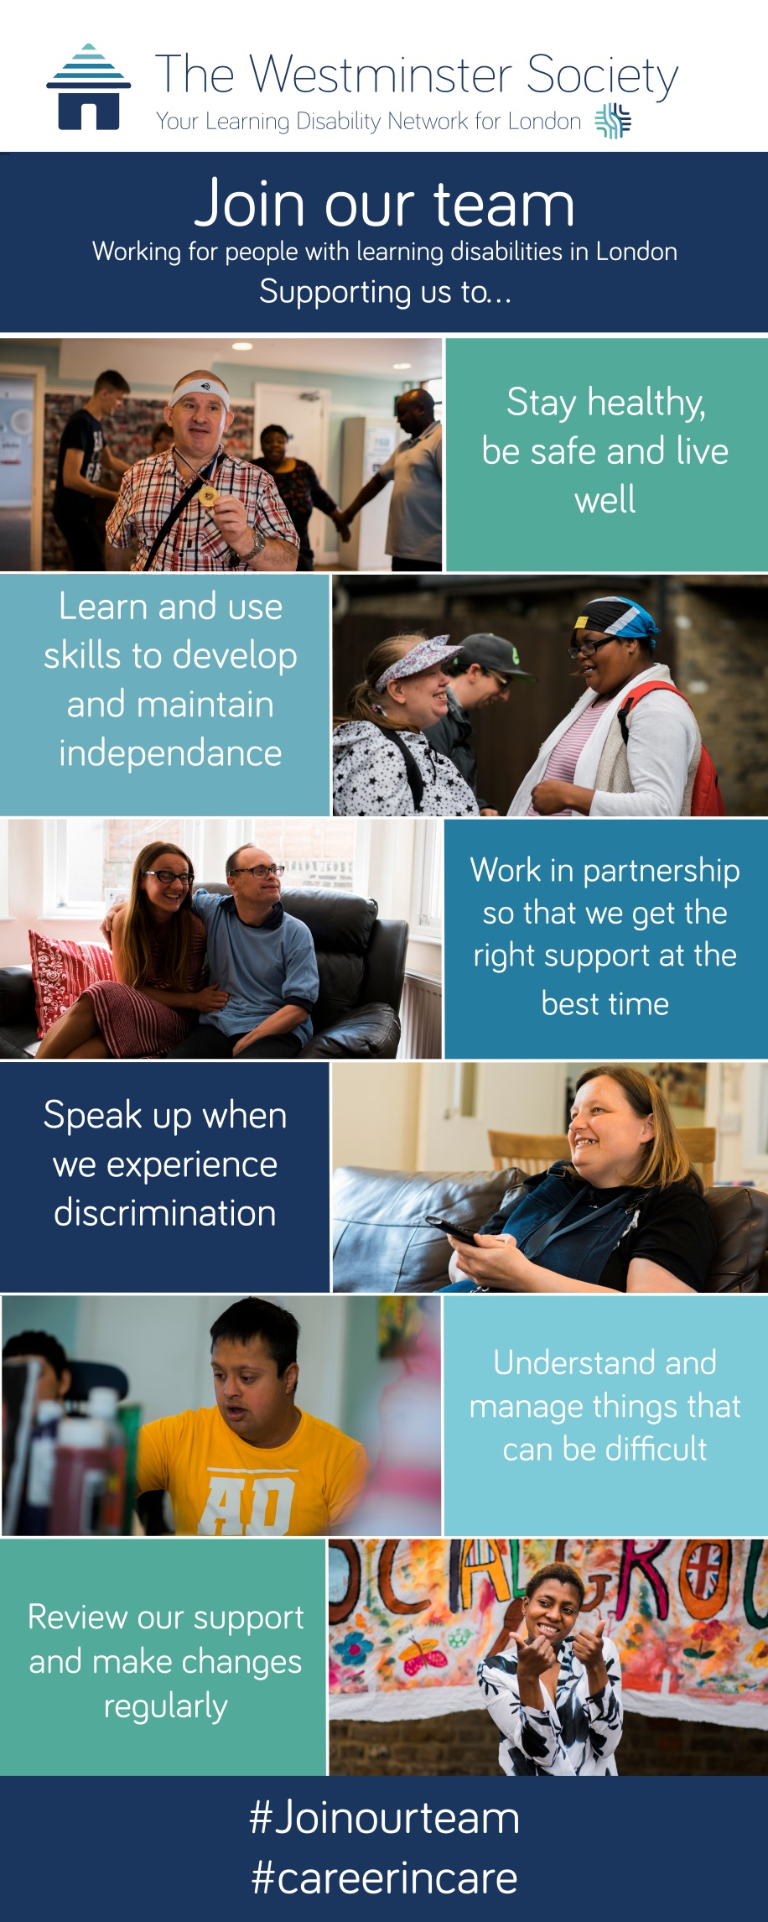

**Make a difference**

**as a support worker at**

**LDN London**

LDN London (Learning Disability Network London) is an award-winning charity with over 50 years’ experience supporting people with learning disabilities in London. As a support worker you will help people with learning disabilities to live safe, fulfilling, and dignified lives in supported accommodation or their own home.

Join us at one of over 40 locations in Westminster, Camden, Islington, and Kensington & Chelsea.

Salary £21,157 per year

(London Living Wage)

Hours Full time, part time or Sessional contracts available

Day or night hours available

Read our story and apply for a job:

[www.ldnlondon.org](http://www.ldnlondon.org)

Find out more information:

[recruitment@ldnlondon.org](mailto:recruitment@wspld.org)

020 8968 7376

**How can you make a difference as a support worker?**



**Who do we support?**

Primarily we support people with learning disabilities, many will also have additional needs, although not defined by a “diagnosis”, examples of the types of learning disabilities we support are:

* People with profound and multiple learning disabilities - people with limited speech and movement who have high risk health needs. They have varying methods of communication and often have high levels of support, sometimes requiring 2 to 1 support. Often people will require support with moving and handling and may use a specialist wheelchair which may need to be pushed for considerable periods. Also, people living in these services regularly require intimate personal care.
* People with autism
* People who have mental health needs, who need support in managing challenges and can become very anxious
* People who are getting older and have poor health and less independence and sometimes dementia. We support people to remain in their home, including end of life care.

**What does being a Support Worker involve?**

As you are supporting people to live their life, you will find that no two days and no two people you support are the same, so you need to be ready for the unexpected!

Depending on their needs, you the support you give could include helping people with:

* getting up and out of bed
* preparing and eating food
* cleaning and laundry
* going shopping
* visiting friends or entertaining them when they visit
* undertaking leisure activities like going to the cinema or to the zoo
* helping people to develop communication skills and friendships
* supporting managing money
* supporting any health needs, such as taking medication, going to health and other appointments, recording relevant information, and liaising with others.
* supporting people to visit to cultural / faith centres, out to leisure spaces (gyms, swimming etc), take on holiday (within UK and abroad)
* supporting people to achieve their life aims and ambitions
* attending educational settings (college etc)

* visiting friends or entertaining them when they visit
* moving and handling tasks, including using hoists
* wheelchair pushing (including large specialist ones)
* personal care (washing, going to the toilet, oral hygiene care, support when menstruating / incontinence – changing pads)
* supporting with dressing and undressing
* sleep ins (Sleeping at house/flat/service in case there is an emergency) – not night staff
* working shifts on rotation, including early, late, working weekends and lone working

This is a summary; additional duties will be required within your role.

**Where will you work?**

We will normally allocate you according to your skills and experience and current vacancies. You can request to work in a particular location. You will work either:

* in a place where several people live together or in their own flat / room (Registered Care or Supported Living)
* in a service where they stay for a few nights to a few months to offer a break from home or while finding a permeant home (Respite)
* where we visit people in their home in the community (Outreach)

The level of support given ranges from “drop-in” to 24/7 support.

**How will you deliver this support?**

To ensure support is high quality, effective, and delivered in a safe and stimulating environment you will:

* involve the people we support as much a possible when planning and doing those activities
* help the people we support in meetings and social settings to ensure they are included, consulted, and listened to
* comply with health and safety requirements, undertake health and safety checks, comply with use of PPE and Infection Control Guidance
* record things appropriately in logs and handovers
* undertake regular COVID-19 testing and be fully vaccinated against Covid-19
* ensure you tell your colleagues about anything they should know at the end of your shift, so support continues seamlessly
* respect people’s dignity and property
* be alert to, challenge, and report disrespectful behaviour, potential abuse, and misconduct
* attend and participate in your induction, training sessions and meetings
* report any incidents or accidents that occur
* lead shifts as and when necessary
* use the training and follow the specific guidelines in place for each person.

**How will we support you?**

We will support you by giving you:

* a detailed induction so you will understand the expectations of the people we support, your job and how to do it
* regular supervision, appraisal, and feedback
* training on specific tasks and activities
* developmental opportunities, so you can develop your skills
* opportunities to apply for promotion within LDN London
* generous holiday entitlement, that increases the longer you work for us
* an employee assistance scheme and occupational sick pay.

If you have not already done so you will need to successfully complete a Level 2 Diploma in Health and Social Care within your probationary period of employment.

**What experience and skills do you need for this job?**

We will consider you irrespective of your previous experience. You don’t need to have experience working in social care, but you will need to:

* **live our values**
* **be caring**
* **communicate well**
* **be responsible**
* **be able**

These standards are used to appoint staff and are set out in more detail overleaf.

**How do you apply?**

Download an application form from our website and return it to: [recruitment@ldnlondon.org](mailto:recruitment@ldnlondon.org)

Email us or speak to us if you have any questions – 020 8968 7376

**How we will select you - our standards for our support workers**

The skills, knowledge, and attributes you will need to show are detailed below. These standards are used to decide whether to give you a job and to assess your performance if appointed.

**You live our values**

* You want to support people with learning disabilities
* You are friendly and enthusiastic
* You take pride in your work
* You work collaboratively with colleagues as part of a team
* You help and encourage the people we support to achieve their personal goals
* You are punctual
* You believe that people with learning disabilities have the right to:
* Inclusion – to be part of the community
* Consultation – to have information and support to make choices
* Choice – to be listened to about what they want and need
* Respect – to be treated as a valued individual
* Achieve – to be supported to do the things they always wanted to do
* Quality – to have the right to be safe happy and live well

**You are caring**

* You put the people we support first
* You are patient
* You treat people with dignity and respect
* You promote healthy living and independence in the people we support
* You support people with positive behaviour
* You help people with limited communication skills to be heard and understood
* You respond to emerging health, care, and support needs

**You communicate well**

* You communicate respectfully
* You listen to people and consider what they say
* You share information appropriately
* You speak and write clearly and accurately
* You have IT skills appropriate to your role
* You can complete records accurately and write reports of incidents etc.
* You solve problems with your colleagues in private

**You are responsible**

* You are honest and trustworthy
* You can work on your own and take decisions when necessary
* You understand risk and danger and act to ensure you, the people we support, and your colleagues stay safe
* You are aware of safeguarding risks and raise concerns appropriately
* You support service users according to their support plans and with medication as necessary
* You take responsibility for your own development, learning on the job and in formal settings
* You reflect on your own work and learn from events
* Unless you are exempt, you are vaccinated against Covid-19

**You are able**

* You carry out your job to the best of your abilities
* You are aware of and follow all relevant guidelines, policies, and procedures
* You are flexible and able to deal with unexpected events
* You have maths skills appropriate to your role
* You take pride in your workplace
* You are able to support people with personal care
* You enable people to move and, where necessary, push large specialist wheelchairs and use hoists etc.
* You support people to be active and go out in their community
* You can work on a rota basis as appropriate to your role and service

**Additional considerations**

The following additional considerations are used to help us and you assess which type of service would suit you best.

To work with people with profound and multiple learning disabilities you should have an interest in health matters and helping individuals to play an active part in their local community.

To work with people with autism or mental needs you should be proactive, be able to respond to unexpected situations, work collaboratively with other professionals, and understand and follow positive behaviour support plans and specialised guidance.

To work with people who are aging or with dementia you should be able to provide personal and meaningful end of life care, be patient and supportive, and understand any additional needs or specialist support requirements.

To work in outreach you should be creative, good at problem solving, and be able to work alone in the community. For outreach work we normally expect you to already have experience working with people with learning disabilities.